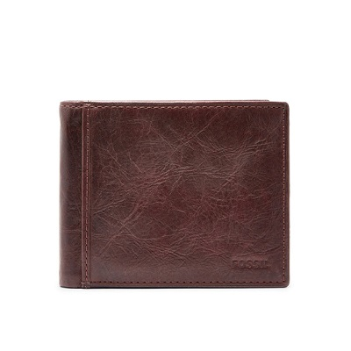

INGRAM RFID BIFOLD WITH FLIP ID

PRODUCT DETAILS

**Silhouette: Bifold**

**Exterior Material: Leather**

**Interior Details: 1 Bill Compartment, 2 ID Windows, 2 Slide Pockets, 8 Credit Card Slots**

**Measurements: 4.38"L x 0.75"W x 3.5"H**

**Warranty: 1 Year Limited**